Soli Sensor Setup Guide

Status: Complete Authors: [ngillian@google.com](mailto:ngillian@google.com)  **March 8th 2021**

Confidential - Do not distribute outside of the NDA.

# Overview

This brief document summarizes how to set up and run the Soli Sensor for the first time.

# Hardware Setup

Carefully snap the Soli sensor (green unit) on to the red breakout board and connect a micro USB cable to the specific USB port as shown below.

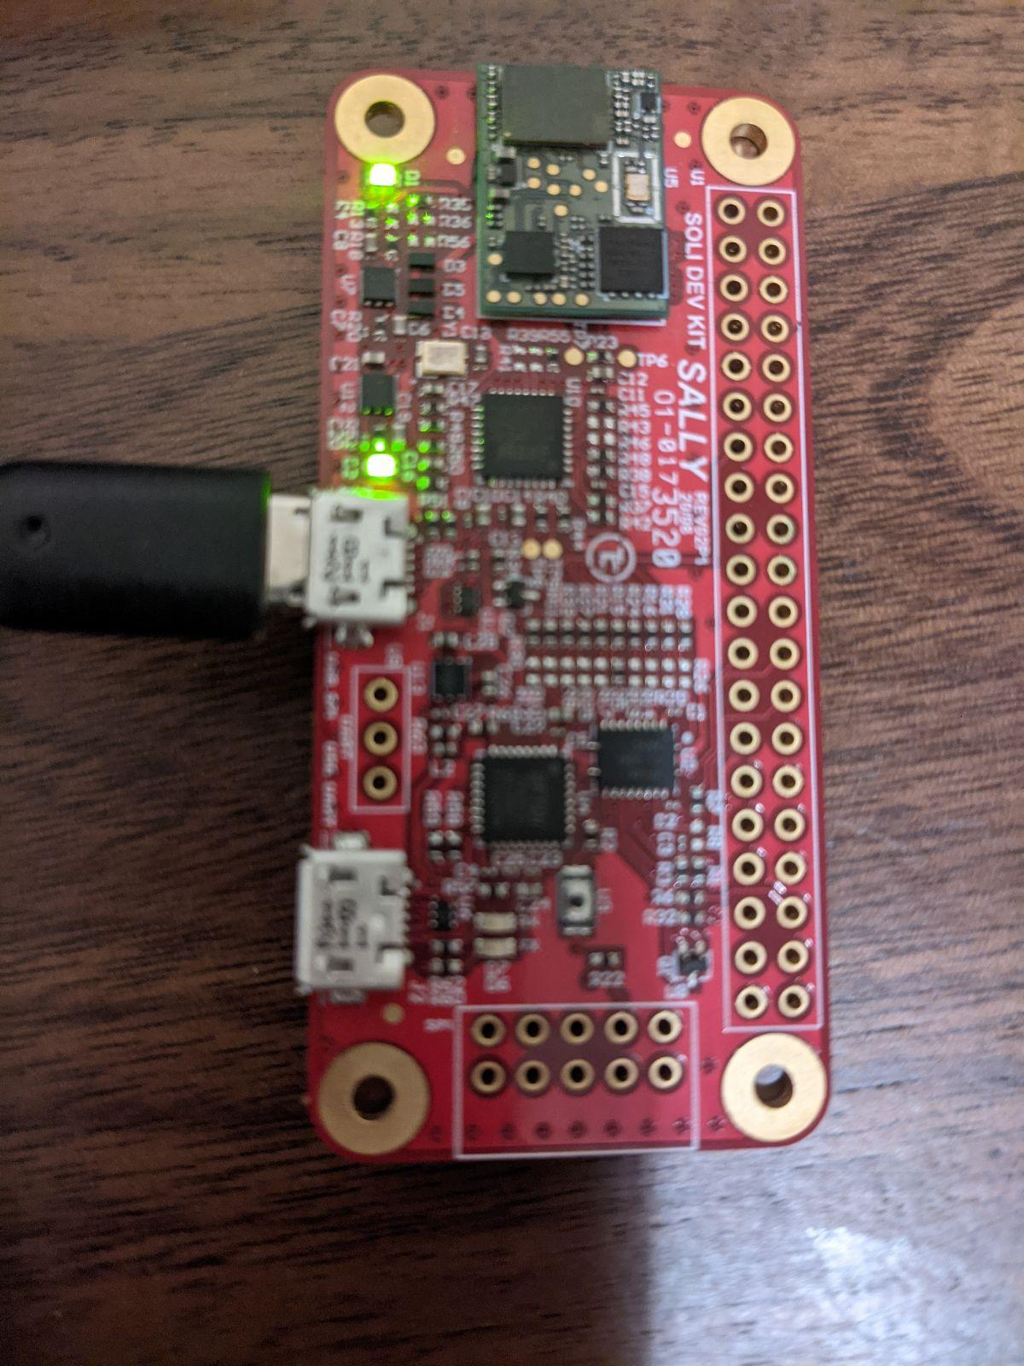

Connect the USB to your Linux machine and you should see the Soli hardware light up as shown above. Note that the USB cable must support data, and not just power.

# Software Setup

Download the [latest Soli library](https://drive.google.com/drive/folders/1na7XkbQRH42Fc8HdTK82qHFwUFn1SMbX?usp=sharing) to your Linux machine and unzip the contents to a convenient location.

Run the main install script:

| ./install.sh |
| --- |

If this installs successfully, try and make and run the example.

# Run the example

Run the main install script:

| cd examples  make  sudo ./main |
| --- |

If successful, you should see logs along the lines of:

| sudo ./main  I | MustangClient.c | McInvertGpioLogic:511 | GPIO logic inversion is DISABLED  I | FtdiClient.c | openSpiConnection:309 | Let FTDI driver settle...  I | MustangClient.c | McSetup:71 | SPI interface connected  I | MustangClient.c | McSetup:77 | GPIO interface connected  E | MustangClient.c | McInit:131 | MustangClient already initialized  I | MustangClient.c | McSetup:89 | SPI interface registered  I | MustangClient.c | McSetup:100 | GPIO interface registered  I | MustangClient.c | McConnect:334 | MEM_ELEC 0x102  I | MustangClient.c | McConnect:337 | You are currently using a PRODUCTION grade DSP  I | MustangClient.c | McSetup:106 | MustangClient connected  I | MustangClient.c | McSetup:108 | MustangClient setup completed  Got radar data.  -burst id: 1  -DSP timestamp: 626784  -num chirps per burst: 16  -num samples per chirp: 64  -num rx channels: 3  -radar data:  1844 1780 1736 1706 1678 1658 1644 1632 1624 1620 1612 1600 1586 1576 1572 1574 1575 1576 1578 1576 1566 1557 1552 1551 1554 1565 1576 1582 1586 1590 1594 1604 1619 1634 1656.... |
| --- |